**Assignment - 6 A Job Ready Bootcamp in C++, DSA and IOT**

Use any loop

**1. Write a program to calculate sum of first N natural numbers**

#include<stdio.h>

int main()

{

int n,sum;

printf("Enter how many first natural numbers to sum ");

scanf("%d",&n);

while(n>=1)

{

sum+=n;

n--;

}

printf("\nSum of natural numbers is %d",sum);

return 0;

}

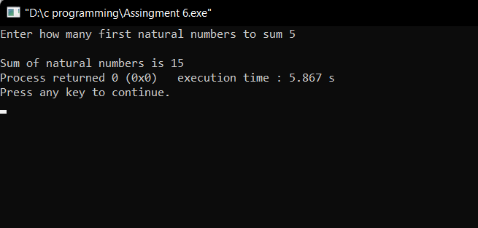

**2. Write a program to calculate sum of first N even natural numbers**

#include<stdio.h>

int main()

{

int n,sum;

printf("Enter how many first even natural numbers to sum ");

scanf("%d",&n);

while(n>=1)

{

sum+=n*2;

n--;

}

printf("\nSum of even natural numbers is %d",sum);

return 0;

}

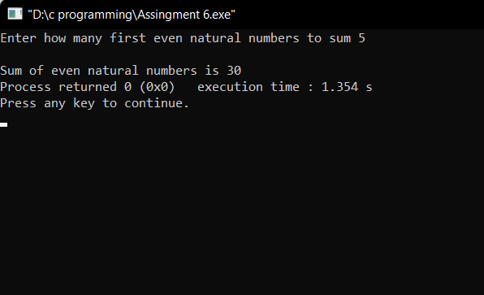

**3. Write a program to calculate sum of first N odd natural numbers**

#include<stdio.h>

int main()

{

int n,sum;

printf("Enter how many first odd natural numbers to sum ");

scanf("%d",&n);

while(n>=1)

{

sum+=n*2-1;

n--;

}

printf("\nSum of odd natural numbers is %d",sum);

return 0;

}

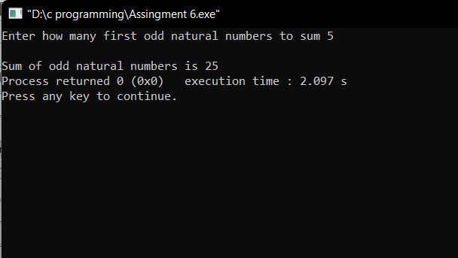

**4. Write a program to calculate sum of squares of first N natural numbers**

#include<stdio.h>

int main()

{

int n,sum;

printf("Enter how many first natural number square to sum ");

scanf("%d",&n);

while(n>=1)

{

sum+=(n*n);

n--;

}

printf("\nSum of squares of first n natural numbers is %d",sum);

return 0;

}

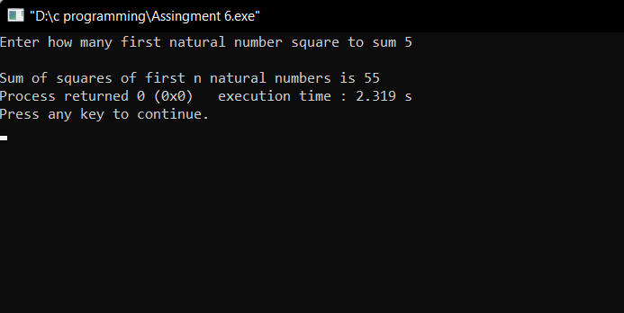

**5. Write a program to calculate sum of cubes of first N natural numbers**

#include<stdio.h>

int main()

{

int n,sum;

printf("Enter how many first natural number cube to sum ");

scanf("%d",&n);

while(n>=1)

{

sum+=(n*n*n);

n--;

}

printf("\nSum of cubes of first n natural numbers is %d",sum);

return 0;

}

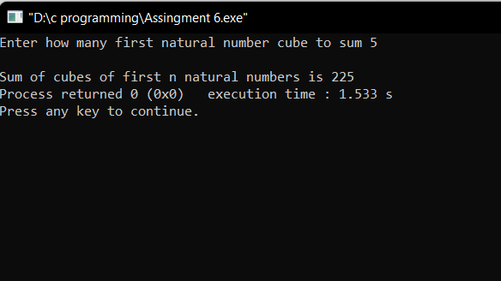

**6. Write a program to calculate factorial of a number**

#include<stdio.h>

int main()

{

int n,fact=1;

printf("Enter a number to calculate their factorial ");

scanf("%d",&n);

while(n>=1)

{

fact*=n;

n--;

}

printf("\nFactorial of the number is %d", fact);

return 0;

}

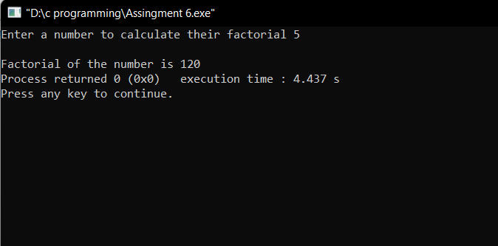

**7. Write a program to count digits in a given number**

#include<stdio.h>

int main()

{

int n,count=0;

printf("Enter a number to count their digits ");

scanf("%d",&n);

while(n!=0)

{

count++;

n=n/10;

}

printf("\nNumber of digits in number are %d", count);

return 0;

}

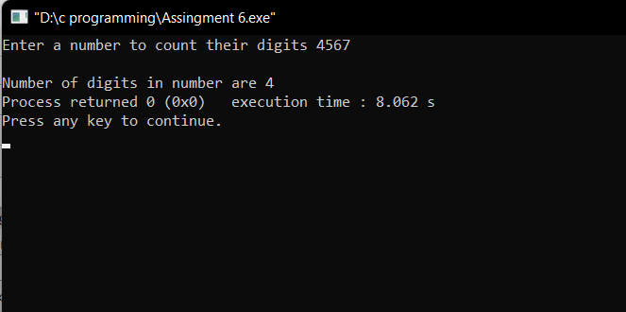

**8. Write a program to check whether a given number is a Prime number or**

**Not**

#include<stdio.h>

int main()

{

int i=2,n,flag=0;

printf("Enter a number ");

scanf("%d",&n);

while(i<n)

{

if(n%i==0)

{

flag=1;

break;

}

i++;

}

if(flag==1)

printf("Not prime number");

else

printf("prime number");

return 0;

}

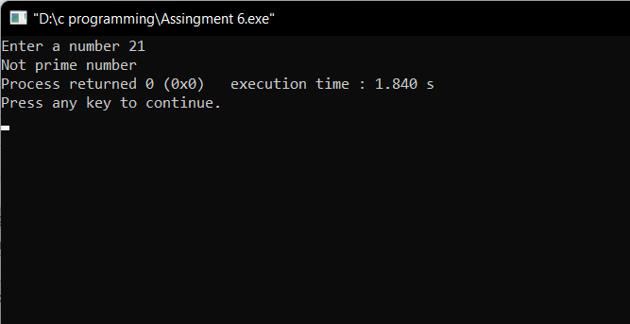

**9. Write a program to calculate LCM of two numbers**

#include<stdio.h>

int main()

{

int a,b,i;

printf("Enter two number ");

scanf("%d %d",&a,&b);

for(i=1;i<=(a*b);i++)

{

if( (i%a==0) && (i%b==0) )

{

break;

}

}

printf("LCM is : %d",i);

return 0;

}

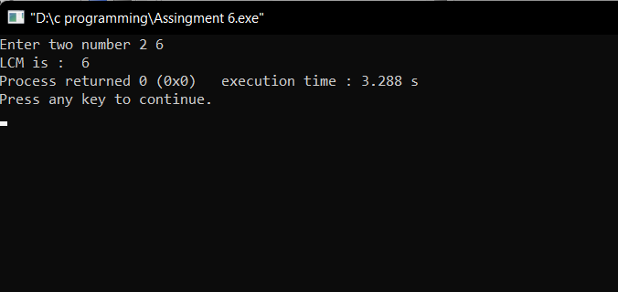

**10. Write a program to reverse a given number**

#include<stdio.h>

int main()

{

int n,remainder,reverse=0;

printf("Enter a number ");

scanf("%d",&n);

while(n!=0)

{

remainder=n%10;

n=n/10;

reverse = reverse*10 + remainder;

}

printf("Reverse is %d",reverse);

return 0;

}

